**4. Run a basic SonarQube Scan and show Dashboard with 3 types of issues i.e., bugs, vulnerabilities, and code smells.**

Pre-requisite: Github repository should be present

1. Login to sonarcloud.io with your Github account.

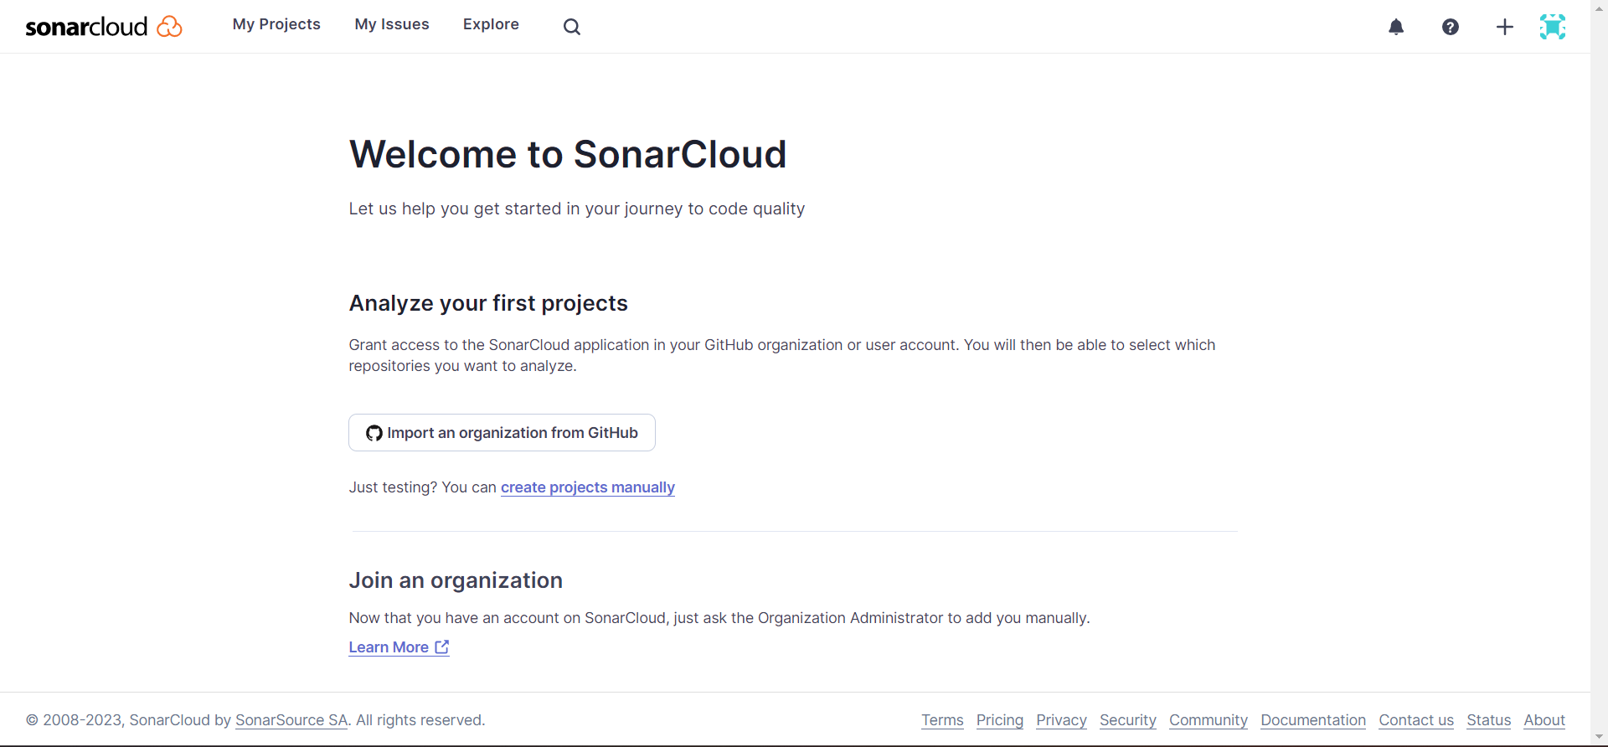

2. Click Import an Organisation from Github.

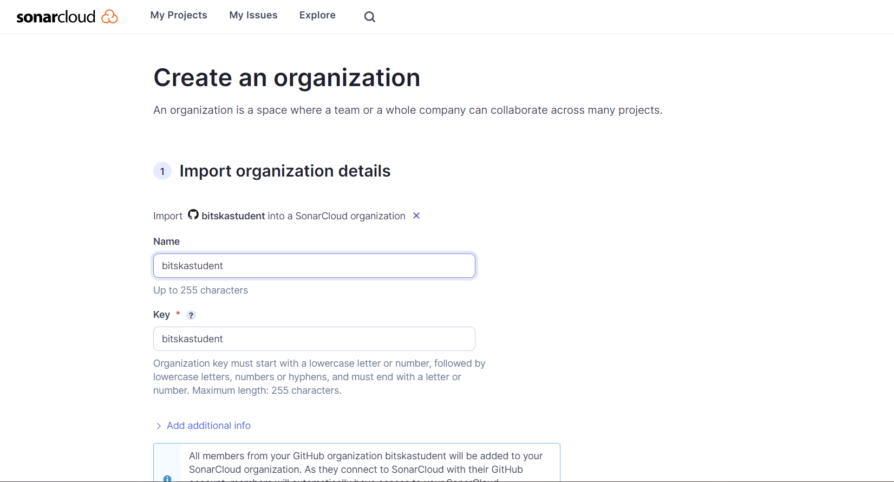

3. Click on Create Organisation and then select the repository you want to analyse and click on Set Up.

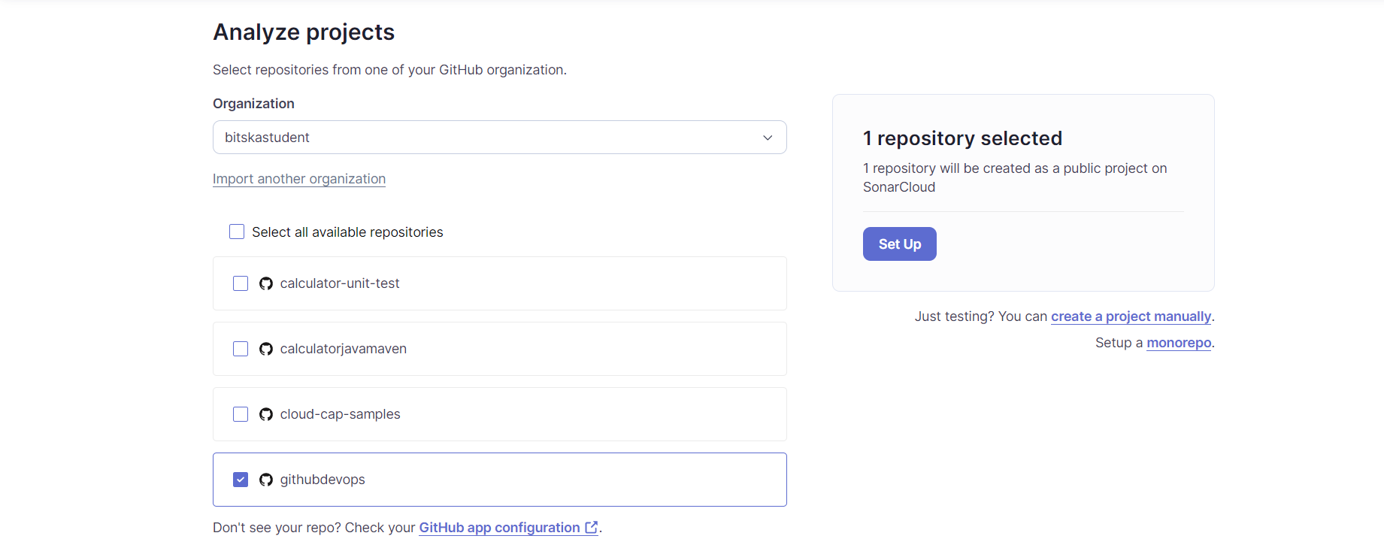

4. Click on My Project to see the overview of all the projects.

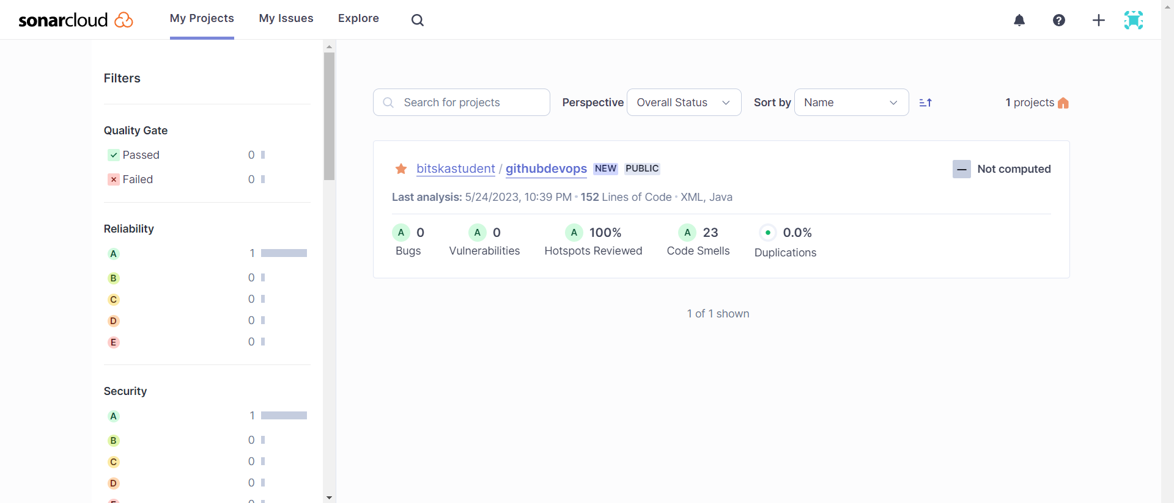

5. Click on Main Branch then Issues to see the issues in your code.

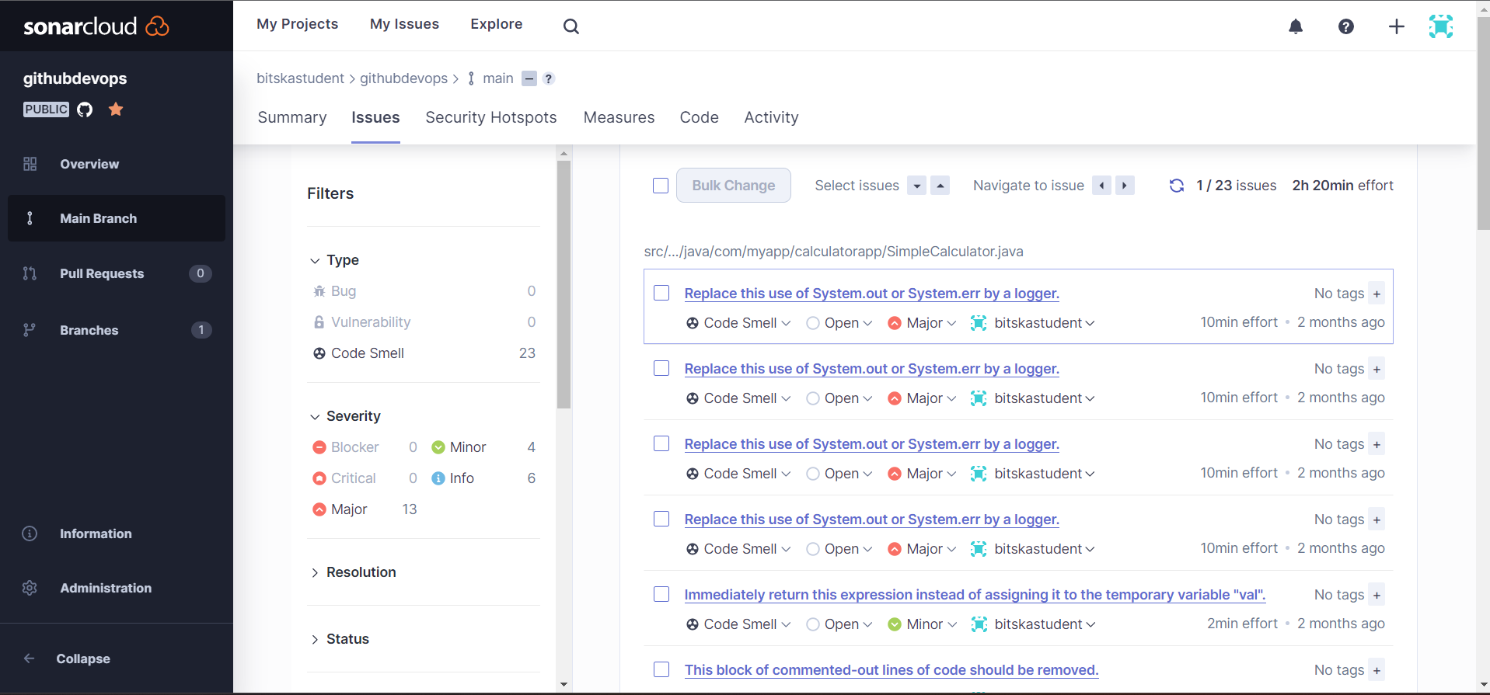

6. In your Github project, push the code to remove any code smells or issues

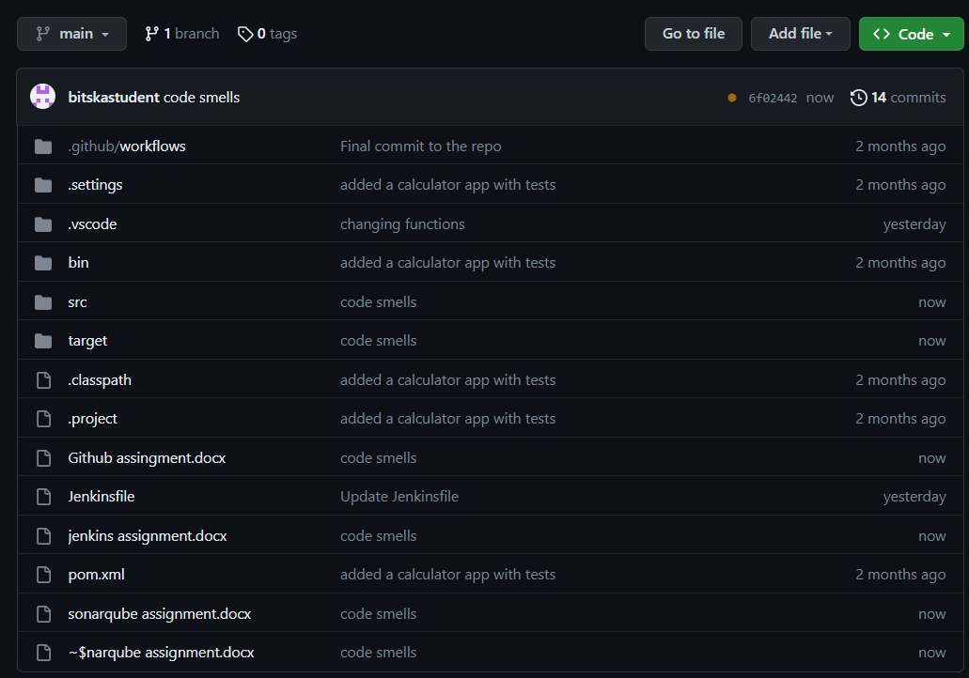

7. As you can see, there are 0 bugs, 0 vulnerabilities and 0 code smells for the project.

